39.26: a) 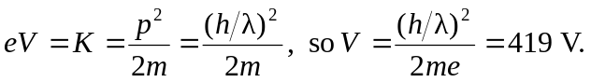
b) The voltage is reduced by the ratio of the particle masses,
